**Git Documentation**

**Step 1:** Go to GitHub account after login into github we see below window.

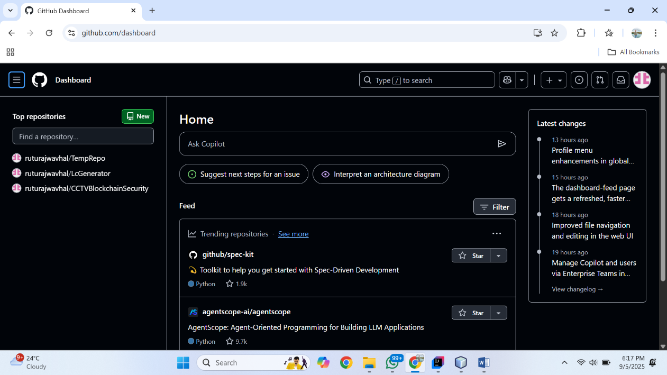

Click on this write side icon



After that Click On Repositories option

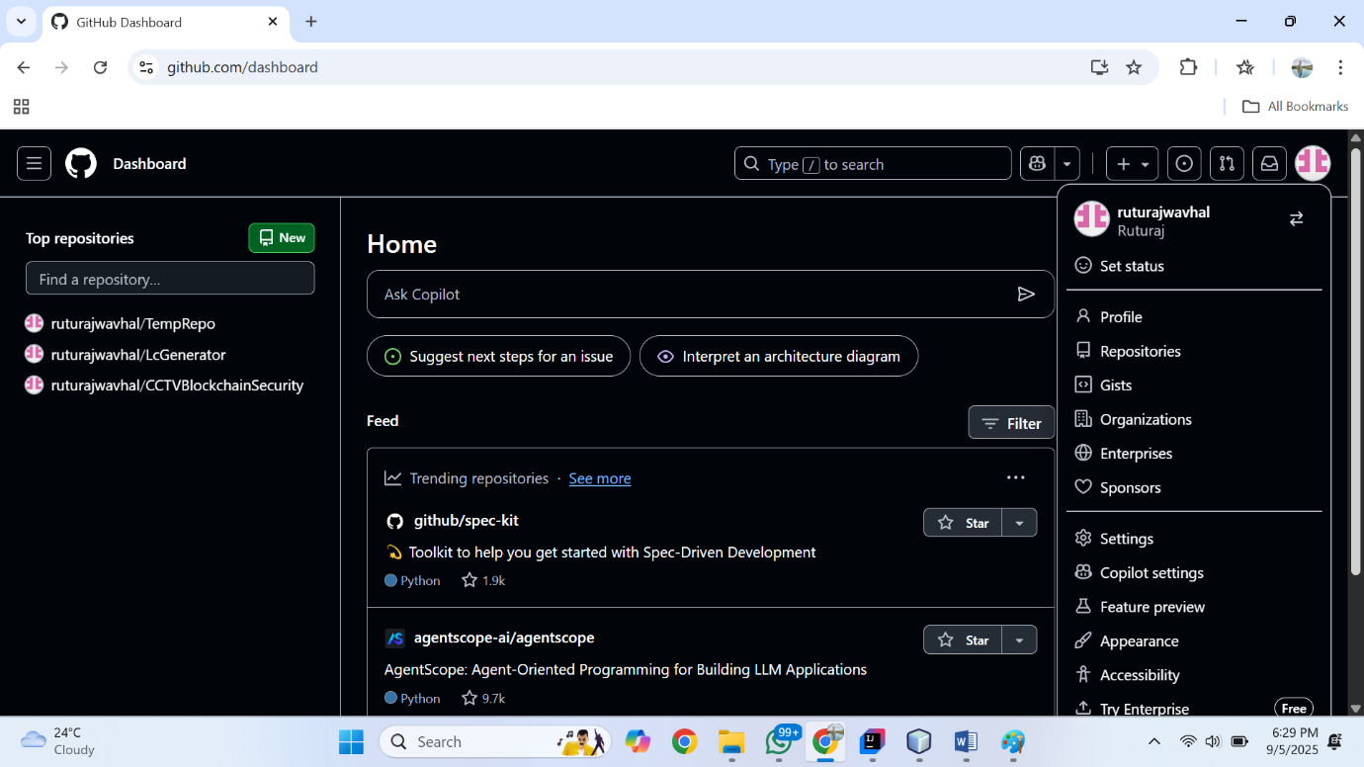

Now we can see all repositories, for creating new repo we need to click on new button

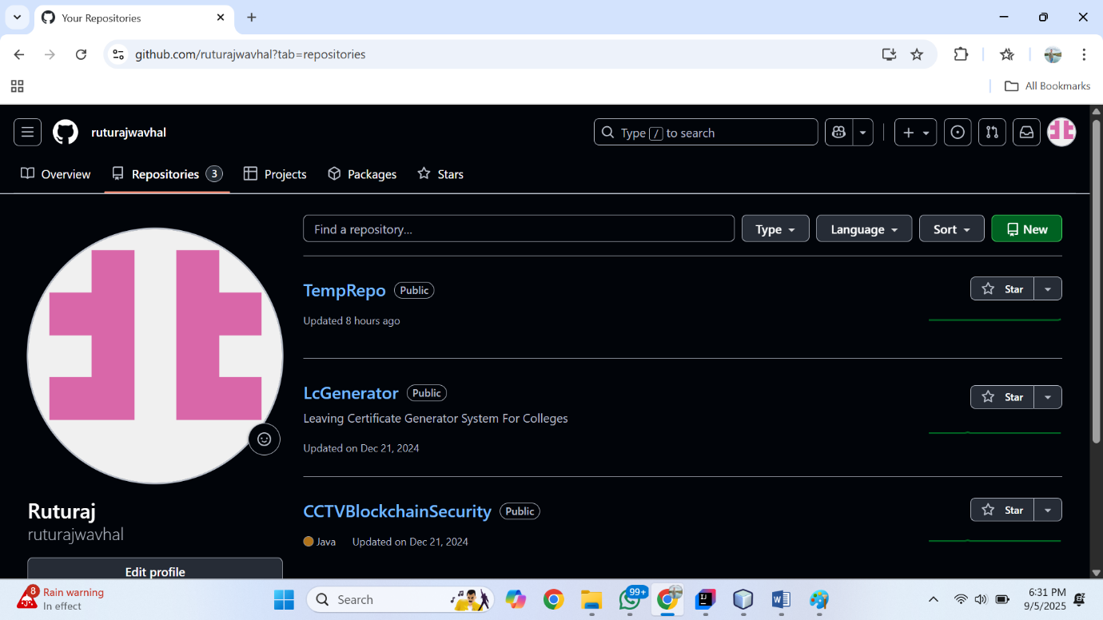

Now we see below window. in that we see two steps first is general in that step we need to type a repository name and its description

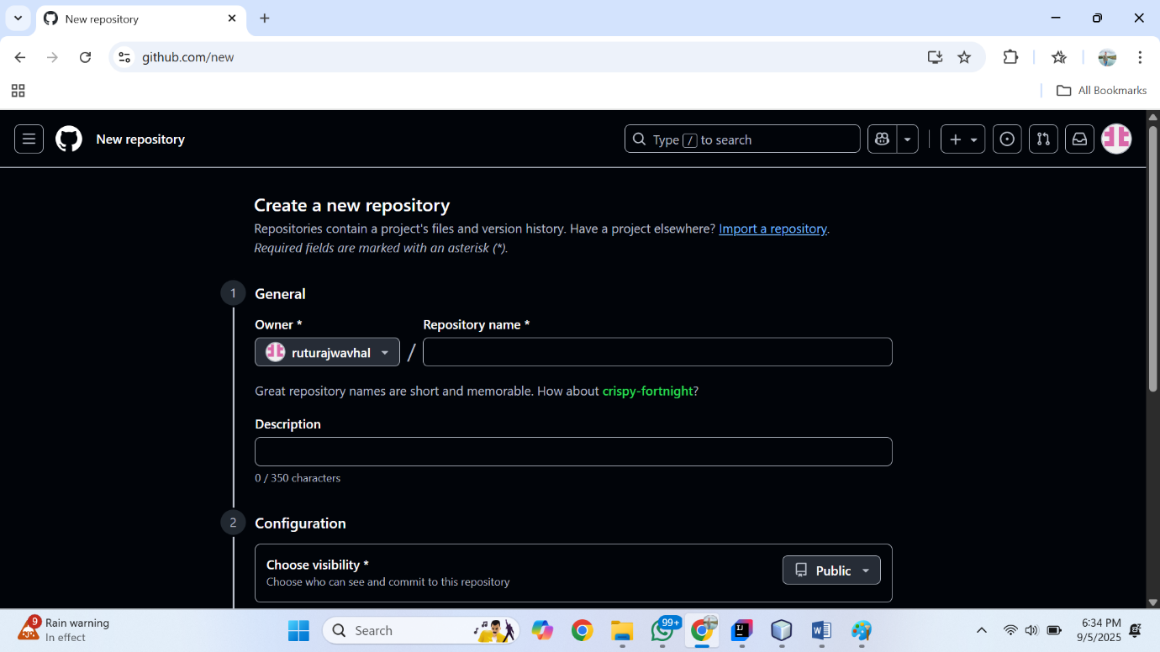

And in second step is configuration in that step we having a option to choose the visibility of our repository which is public or private. After that we see the radio button for add readme file. After that we see the option of add .gitignore which tells git which files not to track. For adding .gitignore we need to choose templete according our requirement. After that we see add license option to add license.

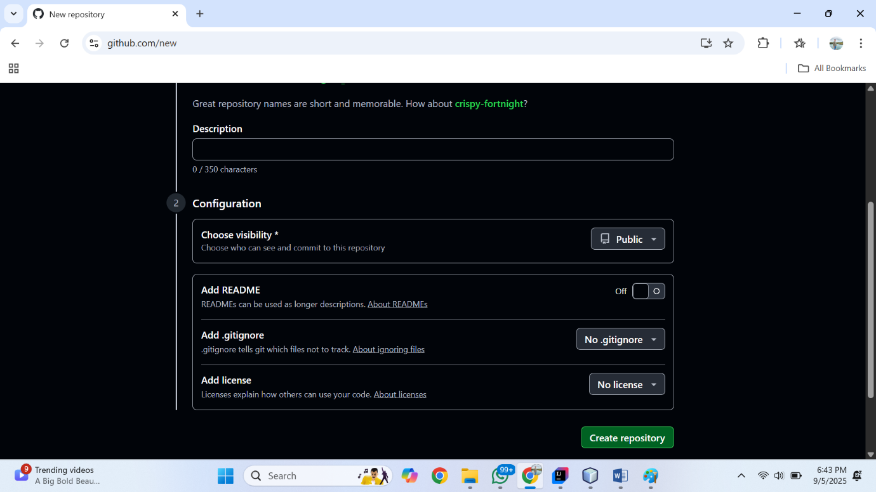

And then we see create repository button to create repository.

After clicking on Create Repository button we see below window.

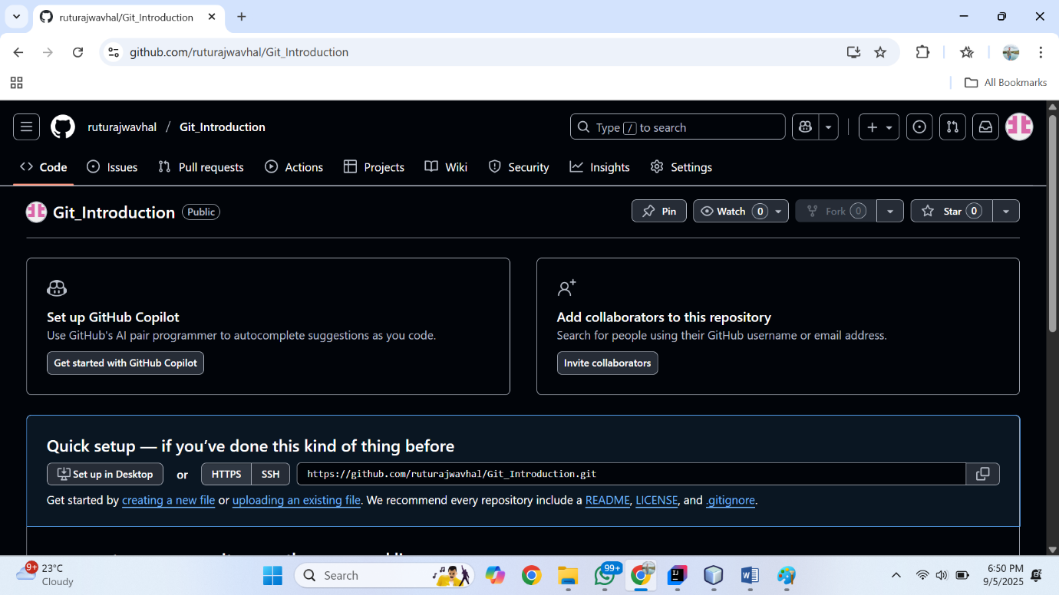

In above window we can see the repository name in this case our repository name is Git_Intorduction and which is public repository.

**Step 2:** Go to file Explorer and create new folder.

**Step 3:** Open the folder and click right and go to show more option and then click on Open Git bash here.

**Step 4:**

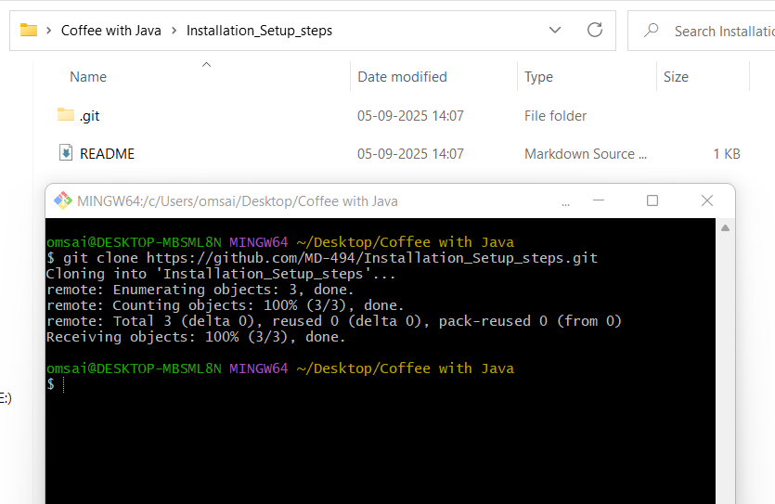

git clone <https://github.com/MD-494/Installation_Setup_steps.git> (repo URL)

This command is used for clone a repository from a remote location to your local machine.

**Step 5:**

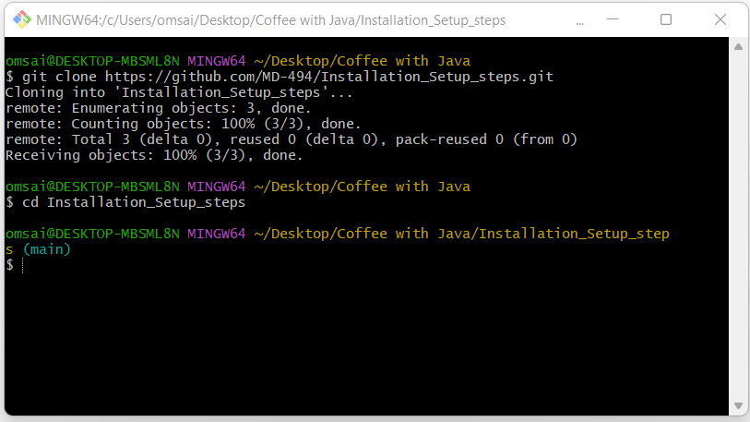

Cd Installation_Setup_steps

This comment is use for change the directory to the specified folder.

**Step 6:**

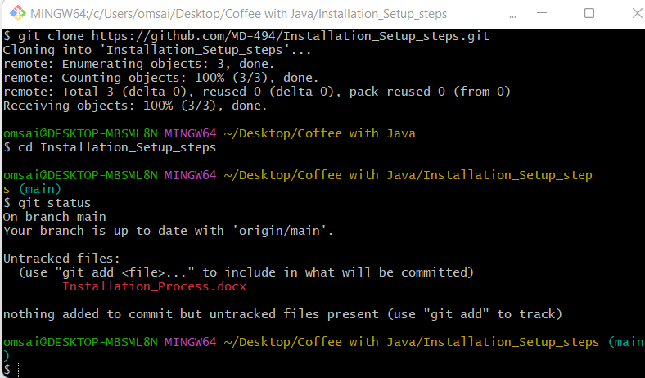

git status

This comment Show the status of changes in the repository (staged, unstaged, untracked files).

**Step 7:**

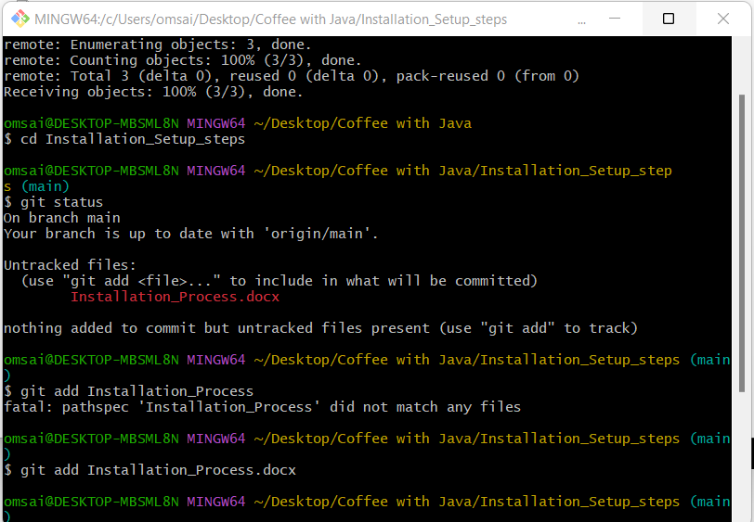

Git add Installation_Process.docx (file name)

This command use for stage a file for the next commit.

**Step 8:**

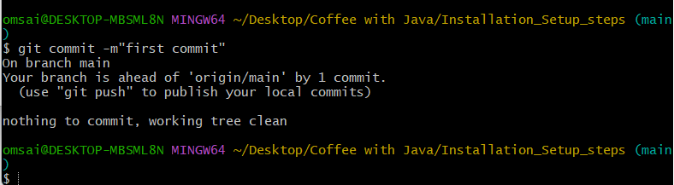

git commit -m”first commit”

This comment is use for commit staged changes with a message.

**Step 9:**

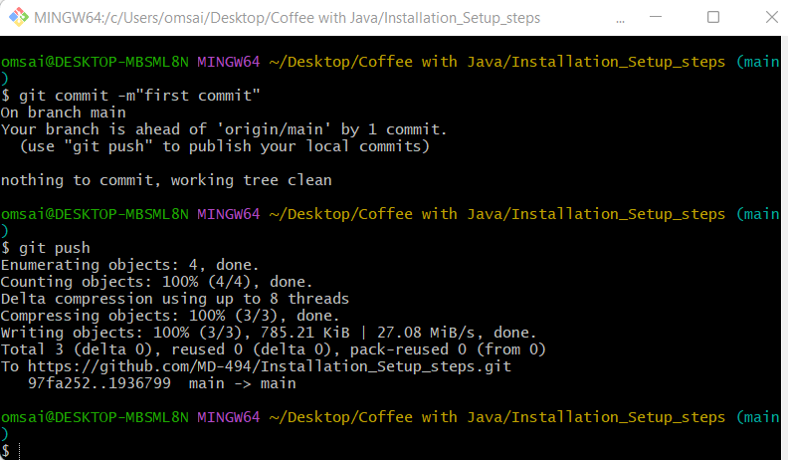

git push

This command is use for Push commited changes to a remote repository.

**Step 10:**

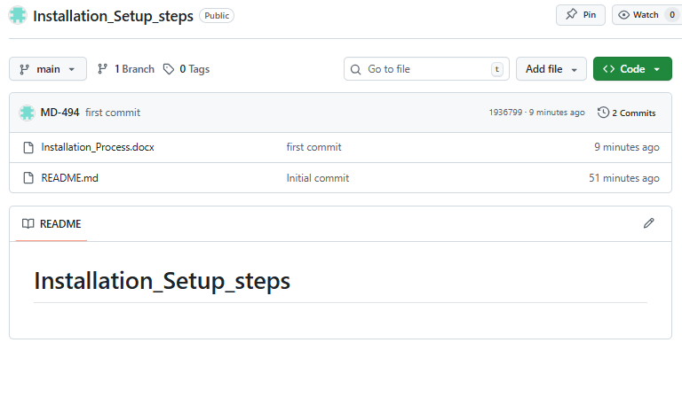

Push file on GitHub Successfully.